**BAL BHARATI PUBLIC SCHOOL, MANESAR**



Academic Year: 2022 – 2023

**PROJECT REPORT ON**

**MACHINE LEARNING PREDICTION MODEL**

Roll No :

Name : Sparsh Agarwal

Class : 12th – ‘A’

Subject : Computer Science

Sub Code : 083

Project Guide: Mrs Mary Rani

PGT (CS)

Bal Bharati Public School, Manesar

**BAL BHARATI PUBLIC SCHOOL, MANESAR**



**CERTIFICATE**

This is to certify that Sparsh Agarwal Roll No. _______ has successfully completed the project work entitled Machine Learning Prediction Model in the subject Computer Science (083) laid down in the regulations of CBSE for the purpose of Practical Examination in class XII to be held in Bal Bharati Public School, Manesar on _________.

*Internal Examiner External Examiner*

Name: __________ Name: __________

Signature: Signature:

|  |  |  |
| --- | --- | --- |
| **SNO** | **DESCRIPTION** | **PGNO** |
| **1** | ACKNOWLEDGEMENT | 4 |
| **2** | INTRODUCTION | 5 |
| **3** | SYSTEM REQUIREMENTS | 6 |
| **4** | ELEMENTS USED | 7 |
| **5** | SOURCE CODE | 8 - 11 |
| **6** | OUTPUT | 12 - 13 |
| **7** | CONCLUSION | 14 |
| **8** | LIMITATIONS | 14 |
| **9** | BIBLIOGRAPHY | 14 |
| **10** | RESOURCES | 14 |

**TABLE OF CONTENTS**

**ACKNOWLEDGEMENT**

I am glad to present my computer science project. This project was given by our respected computer science teacher Mrs Mary Rani. I am thankful to her for giving us such a wonderful and interesting topic for our project.

I would also like to thank my other teachers from my heart. Without their suggestions and feedback, the project would not have achieved such a good outcome.

I hope everyone will like my project and appreciate my hard work.

**PROJECT ON MACHINE LEARNING PREDICTION MODEL**

**INTRODUCTION**

This project is all about a software for school. It helps the Teachers to predict scores of the students. It takes up previous 10 scores of the students and predicts the next (11th) score.

**OBJECTIVES OF THE PROJECT**

The objective of this project is to let the students apply the programming knowledge into a real-world situation/problem and expose the students how programming skills helps in developing a good software.

* Write programs utilizing modern software tools.
* Apply object-oriented programming principles effectively when developing small to medium sized projects.
* Write effective procedural code to solve small to medium sized problems.
* Students will demonstrate a breadth of knowledge in computer science, as exemplified in the areas of systems, theory and software development.
* Students will demonstrate ability to conduct research or applied Computer Science project, requiring writing and presentation skills, which exemplify scholarly style in computer science.

**SYSTEM REQUIREMENTS**

*Recommended System Requirements:*

* Intel®Core™ i3 4300M processor @ 2.6 GHz
* Disk space: 2 to 4 GB
* Operating System: Windows 10, Windows 11
* Python Version: 3.10.1 or higher

*Minimum System Requirements:*

* Intel Atom® or Intel®Core™ i3 processor
* Disk space: 1 GB
* Operating System: Windows 7
* Python Version: 3.8.1

*Software Requirements:*

* Python Version: 3.10.1 or higher
* MySQL server

**ELEMENTS USED**

*Libraries Used:*

* mysql.connector
* tkinter
* pandas

*Functions Used:*

* OLD()
* CHECK()

*Database(s) & Table(s) Used:*

* Database: LMAO
* Table: ReSuLt

**SOURCE CODE**

# IMPORTING DIFFERENT MODULES

import mysql.connector as ms

from tkinter import *

import pandas as pd

# DEFINING OUR GUI WINDOW

root = Tk()

root.geometry("1600x900")  #SCREEN RESOLUTION

# CONNECTING MYSQL WITH PYTHON

connect = ms.connect(host = "localhost", user = 'root', passwd = '1234', database = 'old_results')

print("MySQL successfully connected")

heh = connect.cursor(buffered=True)

heh.execute('create database LMAO')

heh.execute('use LMAO')

heh.execute('create table ReSuLt(oldie float(20))')

connect.commit()

# FUNCTION TO CHECK OLD RESULTS

def OLD():

    # DEFINING GUI WINDOW

    root_2 = Tk()

    root_2.geometry("853x480")

    Title_Label = Label(root_2, text = "Old Results", font = ('Bahnschrift 20 bold underline'))

    Title_Label.pack()

    # SQL COMMANDS

    heh.execute(f"select * from ReSuLt")     # fetch all results

    a = heh.fetchall()

    label_one = Label(root_2, text = f"{a}", font = ('Bahnschrift 15'))

    label_one.pack()

    print(a)

# MAIN FUNCTION TO PREDICT VALUE

def CHECK():

    # ENTRY FIELDS TO FETCH 10 DATA VALUES

    data_1 = entry_1.get()

    data_2 = entry_2.get()

    data_3 = entry_3.get()

    data_4 = entry_4.get()

    data_5 = entry_5.get()

    data_6 = entry_6.get()

    data_7 = entry_7.get()

    data_8 = entry_8.get()

    data_9 = entry_9.get()

    data_10 = entry_10.get()

    # CREATING A DATAFRAME/ROW COLUMN

    df = pd.DataFrame({'SNo':[1,2,3,4,5,6,7,8,9,10],'Data':[data_1, data_2, data_3, data_4, data_5, data_6, data_7, data_8, data_9, data_10]})

    # FETCHING X AND Y COLUMN VALUES FROM THE DATAFRAME

    X = df[['SNo']]

    Y = df[['Data']]

    # IMPORTING THE LINEAR REGRESSION ATTRIBUTE AND CONFIGURING THE LINEAR REGRESSOR

    from sklearn.linear_model import LinearRegression

    reg = LinearRegression()

    # FITTING X AND Y COLUMN VALUES INTO THE LINEAR REGRESSOR

    reg.fit(X, Y)

    # PREDICTING THE DESIRED X COLUMN VALUE

    Y_predict_val = reg.predict([[11]])

    # DISPLAYING THE PREDICTED VALUE IN THE GUI WINDOW

    predicted_value_label = Label(root, text = f"Value {Y_predict_val}", font = ('Corbel 20 bold underline'))

    predicted_value_label.place(x = 600, y = 650)

    # INSERTING THE PREDICTED VALUE INTO THE DATABASE/TABLE TO FETCH IT FOR LATER USE

    heh.execute(f"insert into ReSuLt values({float(Y_predict_val[0][0])})")

    connect.commit()

    print('done')   # confirmation

#--------------------------------------------------------------------------------------------------------------------------

# DEFINING MAIN HEADING ON THE GUI WINDOW

Title_Label = Label(root, text = "Machine Learning Prediction Model - By Sparsh", font = ('Algerian 25 bold underline'))

Title_Label.pack()

entry_label_1 = Label(root, text = "Data 1", font = ('Bahnschrift 15'))

entry_label_1.place(x = 700, y = 95)

# EMPTY FIELD TO ENTER FIRST DATA

entry_1 = Entry(root, width = 25)

entry_1.place(x = 770, y = 100)

entry_label_2 = Label(root, text = "Data 2", font = ('Bahnschrift 15'))

entry_label_2.place(x = 700, y = 145)

# EMPTY FIELD TO ENTER SECOND DATA

entry_2 = Entry(root, width = 25)

entry_2.place(x = 770, y = 150)

entry_label_3 = Label(root, text = "Data 3", font = ('Bahnschrift 15'))

entry_label_3.place(x = 700, y = 195)

# EMPTY FIELD TO ENTER THIRD DATA

entry_3 = Entry(root, width = 25)

entry_3.place(x = 770, y = 200)

#

entry_label_4 = Label(root, text = "Data 4", font = ('Bahnschrift 15'))

entry_label_4.place(x = 700, y = 245)

# EMPTY FIELD TO ENTER FOURTH DATA

entry_4 = Entry(root, width = 25)

entry_4.place(x = 770, y = 250)

entry_label_5 = Label(root, text = "Data 5", font = ('Bahnschrift 15'))

entry_label_5.place(x = 700, y = 295)

# EMPTY FIELD TO ENTER FIFTH DATA

entry_5 = Entry(root, width = 25)

entry_5.place(x = 770, y = 300)

entry_label_6 = Label(root, text = "Data 6", font = ('Bahnschrift 15'))

entry_label_6.place(x = 700, y = 345)

# EMPTY FIELD TO ENTER SIXTH DATA

entry_6 = Entry(root, width = 25)

entry_6.place(x = 770, y = 350)

entry_label_7 = Label(root, text = "Data 7", font = ('Bahnschrift 15'))

entry_label_7.place(x = 700, y = 395)

# EMPTY FIELD TO ENTER SEVENTH DATA

entry_7 = Entry(root, width = 25)

entry_7.place(x = 770, y = 400)

entry_label_8 = Label(root, text = "Data 8", font = ('Bahnschrift 15'))

entry_label_8.place(x = 700, y = 445)

# EMPTY FIELD TO ENTER EIGHTH DATA

entry_8 = Entry(root, width = 25)

entry_8.place(x = 770, y = 450)

entry_label_9 = Label(root, text = "Data 9", font = ('Bahnschrift 15'))

entry_label_9.place(x = 700, y = 495)

# EMPTY FIELD TO ENTER NINTH DATA

entry_9 = Entry(root, width = 25)

entry_9.place(x = 770, y = 500)

entry_label_10 = Label(root, text = "Data 10", font = ('Bahnschrift 15'))

entry_label_10.place(x = 700, y = 545)

# EMPTY FIELD TO ENTER TENTH DATA

entry_10 = Entry(root, width = 25)

entry_10.place(x = 770, y = 550)

# FINAL BUTTON TO CHECK

check_button = Button(root, text = "CHECK", bg = 'black', fg = 'white', activebackground = 'yellow', font = ('Bahnschrift 15 bold'), command = CHECK)

check_button.place(x = 770, y = 600)

# BUTTON TO CHECK OLD RESULTS

no = Button(root, text = 'CHECK OLD RESULTS', bg = 'white', fg = 'black', activebackground = 'yellow', font = ('Bahnschrift 15 bold'), command = OLD)

no.place(x = 850, y = 600)

root.mainloop()

**OUTPUT**

This is how our first execution will look like

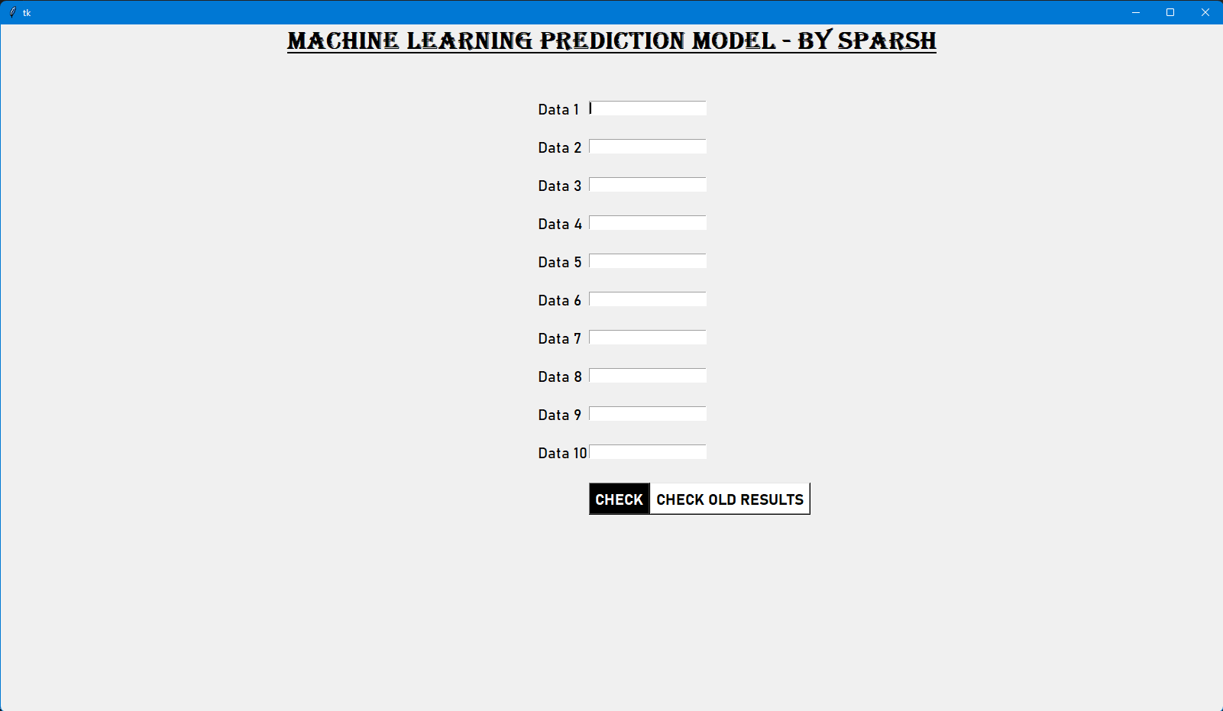

Entering the data values in the empty fields

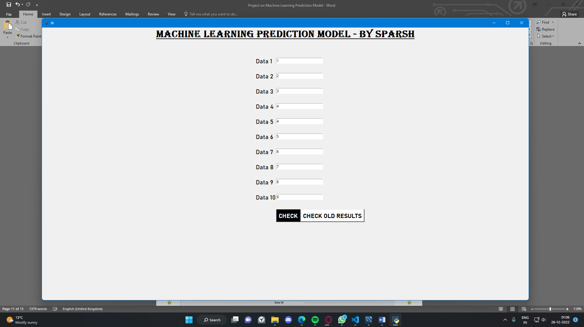

After clicking on the CHECK button, we will get out output

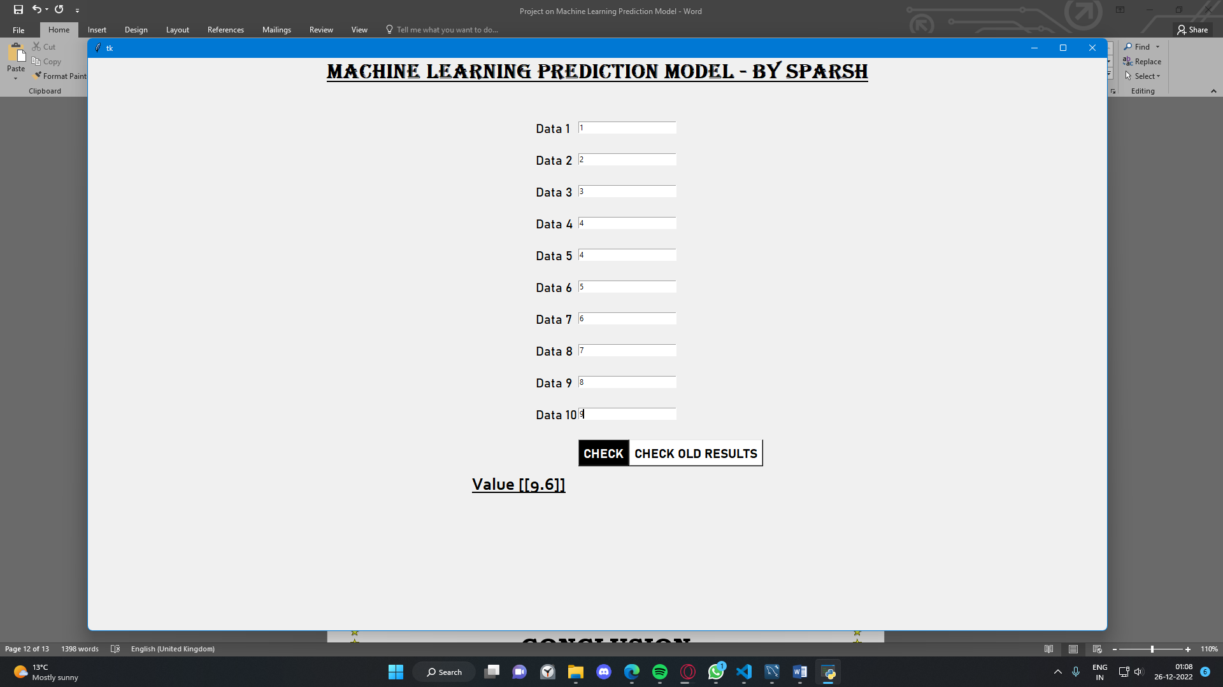

On clicking the CHECK OLD RESULTS button, we will be able to see the previous results

\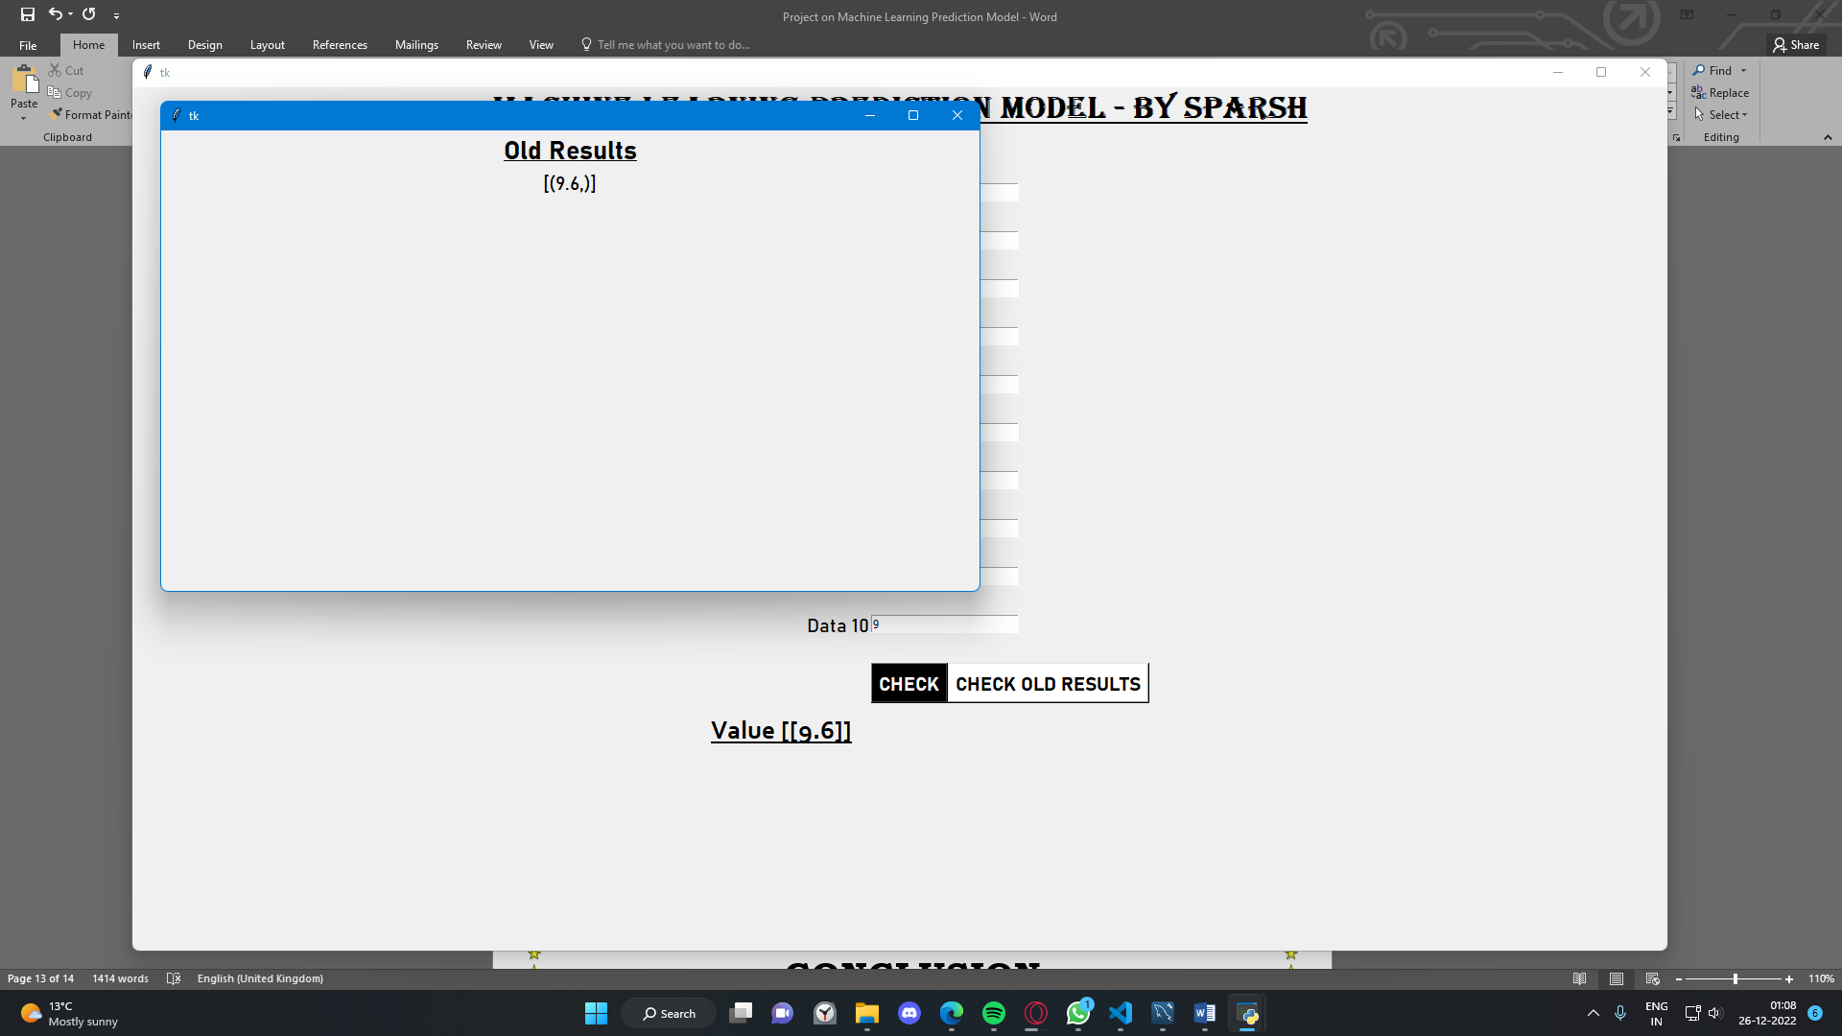

**CONCLUSION**

Machine learning is a hot topic nowadays and it has a wide use across the globe. This project is one of those many applications of Machine Learning.

This software has its advantages and disadvantages but it can surely help with the enhancement of performances of the students by predicting the next scores based on old scores.

**LIMITATIONS**

* It doesn’t support variable type entries (only integer types are welcomed)
* If any of the data value is missing, it will show a ‘missing_value’ error and will not produce any output.
* If the data values vary a lot, then the predicted value may not be the accurate prediction.

**BIBLIOGRAPHY**

* Tkinter UI – **personal notes**
* Linear Regression Model – **personal notes**
* MySQL commands and connectivity – **Preeti Arora’s Computer Science with python**

**RESOURCES**

You can get access to this and my other projects here 🡪

<https://github.com/w47k3r70093/Machine-Learning-MySQL-Project-for-School-Finals>